阅读技巧--主旨大意题、推理判断题
主旨大意题
1.题型特点
要求在阅读和理解全文的基础上对文章进行归纳、概括或评价。解答这种题型时,不能只凭文中的只言片语而断章取义,比如涉及文章的标题(title)、主题(main idea)、结论(conclusion)、结局(end)等有关问题,都需要在细读全文的基础上,结合所学语言知识、背景知识、生活常识等进行逻辑推理和判断,从而挖掘出文章中隐含的信息。
2.主旨大意题主要的设问方式
①What’s the main idea of this passage?
②What is the passage mainly about?
③What does the passage mainly discuss?
④The writer means to tell us that .
⑤The main idea of the passage is that .
⑥The passage is mainly about .
⑦From the passage we can learn/conclude that .
⑧What’s the best title for the passage?
⑨What would be the best title for the passage?
⑩The best title for the passage is .
3.主旨大意题的解题技巧
(1)留心关键词,抓住文章主旨;串联主要细节,推断文章中心思想。所谓关键词,即文章中反复出现的、与主题有关的实词,如名词、动词等。冠词或介词等虚词均不在关键词之列。需要注意的是,为了避免同一词的过多重复,文章有时会使用这个词的同义词、近义词,或用代词指代。我们知道,并不是所有文章都包含明确的主题句,比如大多数记叙文。记叙文的中心思想多隐藏在具体的细节中,作者通过众多的细节事实对一个中心点进行论述。因此,我们必须善于串联主要细节,从中归纳文章的中心思想。
(2)注意段落主题句,归纳文章大意。
段落的主题通常由被称为主题句(Topic Sentence)的句子来表示。主题句有两个功能:①介绍段落的主题(Topic);②阐述控制概念(Controlling Idea),控制概念用以控制段落中句子讨论的内容。
主题句通常是段落的第一句或末尾一句,偶尔在段落中间。我们在阅读非故事性文章(如科普类文章)的时候,主题句尤为明显。有的文章无明显的主题句,主题句隐含在段意之中。
①主题句位于段首
主题句位于段首是由作者先立论,后摆事实讲道理的写作手法形成的。这种段落称作演绎型段落。据有关统计数字表明,在英语议论文或说明文中,有60%~90%的主题句是段落的第一句。
a.寻找主题句
有些段落,有明显的引出细节的信息词,常见的信息词有:for example,an example of,the most important example,first,second,next,then,last,finally,to begin with,also,besides that等。
在阅读中,应尽量利用上述信息词确定主题句的位置。从段落中的for example可以断定,前一句话是主题句。如果无明显的信息词,可先假设第一句话为主题句,在第二句话前面添加一个for example,看看第二句话是否可以支撑第一句话,如果第二句话不能支撑第一句话,便在其他地方找出主题句。
b.选择答案
先彻底弄懂主题句的句意,然后阅读所给的选项,选择与主题句句意相吻合的答案,如主题句的再现,主题句句意的转述或推论等,排除与主题句句意无关的答案,如支撑细节和文章中未曾阐述的事实等。
②主题句位于段末
主题句位于段末是作者采用了先摆事实,后做结论的手法。这种段落称作归纳型段落。
③主题句位于段落的中间
主题句偶尔也出现在段落的中间,但不一定就在正中间。有时,第一句并非主题句,而是承上启下的过渡句。在这种情况下,第二句便成了主题句。此外,主题句也可能是段落的倒数第二句。
推理判断题
1.题型特点
推理判断题主要考查学生对文章言外之意的理解。这种题目有一定难度,往往不能直接从文中找到答案,而必须根据上下文及其相互间的关系或对整篇文章进行深层理解后,才能找到答案。有时甚至还得联系作者的意图、态度等弦外之音、文外之意加以推理,获取作者在文章中没有直接表述出来的态度、观点等。这种类型的题主要有三种形式:语义推理题、结论推理题和出处推理题。语义推理题要求学生根据文章、段落或句子的表层信息推断出深层含义,比如推断文章或段落的中心思想、句子的言外之意等;结论推理题和出处推理题要求学生根据文章中所列举的事实推断出符合逻辑的结论或文章的出处。
2.推理判断题主要的设问方式
①It can be inferred/concluded/seen from the passage that...
②Which of the following conclusions can be drawn according to the passage?
③The writer suggests that...
④The writer uses the example of...to show that...
⑤What’s the writer’s attitude toward...?
⑥What’s the writer’s purpose of writing the passage?
⑦From the passage,we know...
⑧The writer probably agrees that...
3.推理判断题的解题技巧
中考的阅读理解不仅要求考生读懂短文中的每个句子,而且还要求能理解句子之间的内在联系。有的试题要求根据中学生必须具有的常识,对所读的短文进行一定程度的推断;有的试题还要求了解其内在的逻辑关系,从而对所读的内容形成较深层的理解。一般来说,这类问题都不可能直接从原文中找到答案,必须根据原文提供的有关信息,进行合理的推断才能回答。完成推理判断题,通常应注意以下两点:
(1)特别留心特定细节
所谓“特定细节”,就是问题所涉及的范围和对象中的细节事实。它一般包括事实根据、名字(人物或地点)、数字(日期或统计数字)、关键词语的其他表达方法(同义词、近义词、反义词)等。
(2)注意作者的语气和态度
作者的语气和态度通常体现在短文所使用的措辞和句式上。要特别注意感情色彩比较浓重的形容词和副词,特别留心短文句子的长度和结构。从措辞上我们可以推断出作者对所讨论话题的态度(肯定或否定,赞成或反对,褒扬或讽刺,喜好或厌恶等);从句式的长短和结构可以判断出作者讨论问题的语气(郑重其事还是轻松活泼,实事求是还是夸大其词,真挚热诚还是冷嘲热讽等)。
专题训练
一
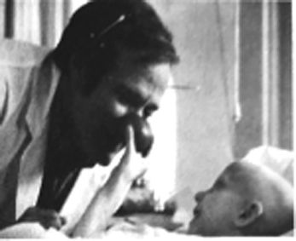
When he was a teenager, Hunter Adams was very unhappy, and he spent many years in the 1960s and 1970s in a special hospital for people with mental(精神的)health problems.
When he left hospital, Adams decided to become a doctor, so he went to Medical School in Virginia, USA. But when he was there he did things in a different way. For example, he didn’t like the doctors’ white coats. He preferred to wear shirts with flowers on them when he visited his patients, and he tried to make them laugh. The doctors at the medical school didn􀆳t like Adams very much because he was too different.
But Adams believed that people in hospital need more than medicine. He saw unhappy and lonely people, and he tried to help them as patients, but as people too. He spent a lot of time with children in the hospital, and often put a special red nose on his face to look like a clown and to make the children laugh.
When he finished medical school and became a doctor, Adams opened his own hospital, called “the Gesundheit Institute”, together with some other doctors. They wanted it to be a place in a different way of working with sick people.
Hunter Adams became famous during the 1980s, and in 1998, Universal Pictures made a film about his life. It was very successful. In the film (called Patch Adams), Robin Williams played Adams. Williams said,“Hunter is a really warm person, who believes that patients need a doctor who’s a friend. I enjoyed playing him.”
1.What probably made Hunter decide to be a doctor?
A.His interest in medicine.
B.His idea of opening a hospital.
C.His early experience as a teenager.
D.His love for the lonely children around.
2.How was Hunter different from other doctors?
A.He was famous before working in hospital.
B.He liked to wear shirts with flowers on them every day.
C.He treated his patients as friends in every way possible.
D.He was good at dealing with people who were mentally ill.
3.What does the underlined word “clown” in paragraph 3 probably mean?
A.木偶 B.小丑 C.外星人 D.蜘蛛侠
4.What can we know from Robin Williams’ words?
A.He thought highly of Hunter.
B.Every doctor needs a patient friend.
C.He became a warm person ever after.
D.A good actor makes a successful film.

二
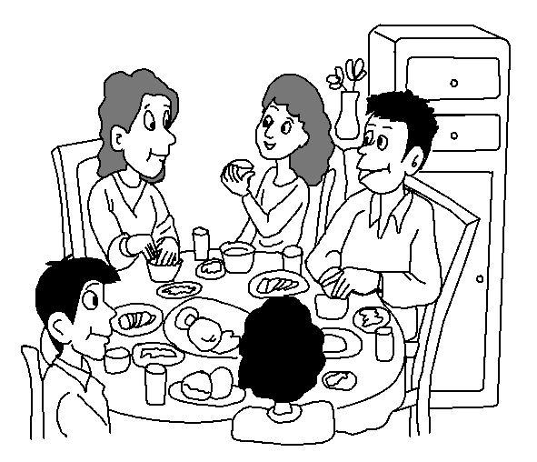
A recent study from a team of South Korean researchers suggests that eating alone often may lead to poor eating habits and poor food choices. Specifically, the study found that men who ate alone more than twice a week had a greater risk of developing high blood pressure, high cholesterol and diabetes.
For children, eating with their families is not only about preventing bad outcomes(结果)—it is also about developing good ones.
In 2014, the Organization for Economic Cooperation and Development(OECD) looked at data from nearly three-quarters of the world’s countries. Among its findings was the fact that students who shared a main meal with their families were less likely to skip school. Children who eat a main meal with their families are also less likely to abuse drugs and alcohol(吸毒酗酒).
In the report, titled “The Importance of Family Dinners(Ⅷ)”, researchers say that “teens who have frequent family dinners are more likely to say their parents know a lot about what’s going on in their lives”. They also claim that when teens say they feel closer to their parents, they are less likely to use drugs and alcohol.
Another study from the University of Montreal found that children who ate with their families experience long-term physical and mental health benefits(好处). These children were physically in better shape and drank fewer sugary soft drinks. These children also seemed to have better social skills and they were less aggressive(好斗的).
Professor Linda Pagani says that mealtimes shared with parents“likely provide young children with first-hand social interactions, discussions of social issues(事件)and day-to-day concerns”. She adds that they may likely help the child have better communication skills with others.
1.What can be the best title for the text?
A.Benefits of eating together.
B.Advantages of eating alone.
C.Ways of developing social skills.
D.Risks of using drugs and alcohol.
2.Children eating with their families are more likely to .
A.drink more sugary soft drinks
B.do well in their studies at school
C.be more socially active and aggressive
D.have a closer relationship with their parents
3.Why is Professor Pagani mentioned in the last paragraph?
A.To introduce her.
B.To add a new point.
C.To explain further.
D.To provide background information.
4.From which is the text probably taken?
A.A travel guide. B.A biology textbook.
C.A cooking instruction. D.A science magazine.
三
Do you have brown hair? Are you taller than other kids your age? These characteristics were decided before you were born. You got your traits from your parents. They passed their traits on to you through genes(基因).
Genes carry codes(代码) for blue eyes or brown eyes. Genes say how tall you will get and what color hair you will have. You got half of your genes from your mother. You got half of your genes from your father. So you have your own set of genes. Each person gets different genes for each body part. That is why you look like—but not exactly like—your brother or sister.
A dominant(显性的) gene shows up most of the time. Brown eyes are dominant over blue eyes. A recessive(隐性的)gene shows up less often. Light hair comes from a recessive gene. Dark hair is more common. Look at the eye color and hair color of the people around you. You will see that this is true.
Genes help to make you who you are. But they don’t tell the whole story. Your genes may help you to be fast and strong. But you still need to learn how to run or swim or skate well.
1.The underlined word “traits” in Paragraph 1 means .
A.characteristics B.experiences
C.achievements D.possibilities
2.According to Paragraph 3, you can see most of the people around you have .
A.brown eyes with dark hair
B.brown eyes with light hair
C.blue eyes with dark hair
D.blue eyes with light hair
3.What is the passage mainly about?
A.Genes carry codes for eyes and hair.
B.Genes help to make you who you are.
C.Genes help you to be fast and strong.
D.Genes make brothers look similar.
四
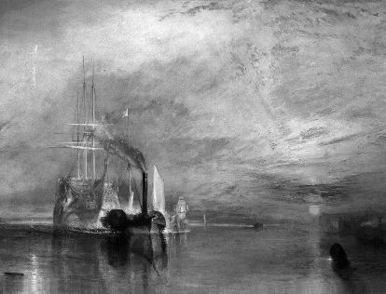
This painting is called The Fighting Temeraire. Temeraire is the name of the big, old sailing ship that you can see on the left of the picture. People chose this picture to be the greatest painting in Britain.
J. M. W. Turner painted it in 1839. It shows the old sailing ship, the Temeraire, on the River Thames near London. There’s a small tugboat pulling the old ship. It’s in fact taking the Temeraire on its last journey. The old ship is going to the breaker’s yard. In the background we can see the sun setting.
The picture, however, is more than just a painting of two boats in the evening. The artist wanted to show the end of an era(时代). The time of the beautiful, old sailing ships is coming to an end. That’s why we see this happening at sunset. In the little, brown tugboat we can see the new industrial era starting. The tugboat is small and dark and it’s making a lot of smoke, but it’s very strong, because it’s pulling the much bigger ship.
The painting shows a real event. Turner watched the Temeraire taking its last journey up the Thames, but he changed some of the details. He painted the old ship white and gold so that it looks like a ghost. In fact, the real ship was black and yellow. We also see the sun setting behind the ship, but in fact, the ship travelled towards the sunset. However, Turner wanted to show the sun setting on the time of the beautiful old sailing ships.
Turner painted The Fighting Temeraire when he was quite old, so perhaps he wanted to show the sun setting on his own life, too. He loved the painting and he never sold it. You can see it today in the National Gallery in London.
1.The Fighting Temeraire .
A.is the name of a big sailing ship
B.was thought the best painting in Britain
C.shows two nice new ships
D.was painted by a famous young artist
2.The old ship was pulled to the yard .
A.to be painted new B.to be repaired
C.to be broken up D.to be sold
3.What does the tugboat stand for according to the passage?
A.The new industrial era.
B.The beautiful old era.
C.The painter’s own life.
D.The white and gold ghost.
4.What can we learn from the last two paragraphs?
A.The color of the real sailing ship was white and gold.
B.In the painting the sailing ship was going towards the sunset.
C.Finally Turner sold this painting because he didn’t like it.
D.Today the painting is kept in the National Gallery in London.
五
Smile Train is a charity(慈善团体) that helps the millions of children around the world, who suffer from a facial defect(缺陷). The defect happens when a baby’s top lip or mouth doesn’t form properly before birth. Eating and drinking is very difficult for these babies. The charity provides free operations, which give these children a new smile, and with it, new hope and a new beginning.
Children with the defect need all the help. Although many sufferers are accepted by their families, sadly, others are not. In some countries, children with this defect are often abandoned at birth because their parents feel ashamed of them or cannot afford the operations. The good news is that the operation is not difficult. It takes less than an hour and costs the family nothing. The charity raises money and finds the right medical volunteers to perform the operations.
A Smile Train doctor from the UK said,“Each child who has the operation is given a second chance at life. After years of staying at home, the children can finally go to school and be happy. Every year I perform hundreds of operations free of cost through Smile Train. Some of the stories I have heard are quite surprising. One newborn baby girl was found abandoned on a train. Luckily for her, she was found and adopted(收养)by a passenger. This lady then heard about Smile Train and brought the baby to our hospital. I did the operation and gave hope to the family. Experienced doctors like me share our skills with local doctors. In this way we make sure that these operations will always be available.”
1.Smile Train is a charity which .
A.provides food and medical care for poor children
B.raises money for all the doctors working in the UK
C.offers free medical help to children with the facial defect
D.gives children without parents new hope and a new beginning
2.The underlined word “abandoned” in Paragraph 2 is closest in meaning to .
A.given up B.dressed up
C.called up D.brought up
3.What did the doctor from the UK think of his volunteer work?
A.Dangerous. B.Surprising.
C.Relaxing. D.Valuable.
4.It can be inferred from the passage that .
A.children with the facial defect are becoming more ashamed than before
B.more doctors are trained to help children with the facial defect
C.fewer baby boys with the facial defect are operated on than girls
D.doctors in Smile Train are always well paid for doing the operations
六
Bath, 97 miles west of London, is the largest city in Somerset, England. It became a World Heritage Site in 1987.
The city got its name from the Roman Baths, which was a place for public bathing in Roman Britain. The water there is naturally heated under the ground. Today visitors are no longer allowed to enter the water. However, the exhibitions there will tell you the history of the Roman Baths. You can see many ancient Roman objects, including the coins that were thrown into the water to show respect for the goddess.
Looking over the city, you will see many old buildings in the color of honey. Among them, the Royal Crescent and the Circus are the most famous. The Royal Crescent is a row of 30 houses in the shape of crescent. The Circus is about 200 meters to the east of the Royal Crescent. It is a huge circle formed with large townhouses. It is divided into three parts of the same length by three entrances* with a lawn in the center. When visiting Bath, you can’t miss these two sites.
The museums in the city are also popular. You can go and appreciate western paintings. If you are interested in the English writer Jane Austen, you can go to Jane Austen Center to know more about her life with her father in Bath. If you come in October, you can even take part in the Bath Film Festival.
With its own style and fantastic sights, Bath attracts millions of tourists from all over the world.
1.The passage is mainly about the in Bath.
A.writers B.paintings
C.festivals D.buildings
2.According to the passage, what can visitors do in the Roman Baths?
A.Take a bath.
B.Play in the water.
C.Enjoy ancient coins.
D.Buy ancient Roman objects.
3.Which of the following is correct about the Royal Crescent and the Circus?
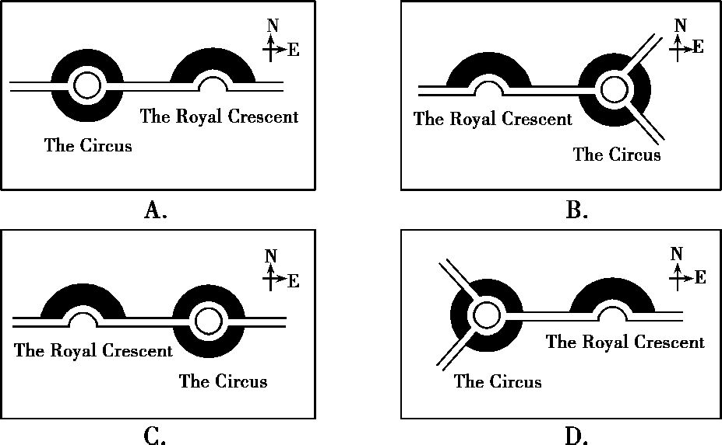
4.Bath is a city .
A.where Jane Austen once lived
B.that got its name from the heated water
C.where a film festival is held all year round
D.that has been a World Heritage Site for 21 years
七
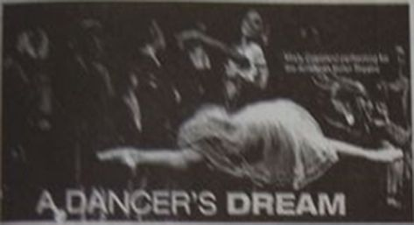
A young woman turns around and around quickly, and jumps high. In the background, a young girl reads a rejection(拒绝) letter from a ballet school. ‘You have the wrong body for ballet,’it says,‘and at thirteen, you are too old.’This was one of the most popular advertisements(广告)of 2014 and it describes American Ballet Theatre’s principal(主要的)dancer Misty Copeland.
This was not a real letter. But Copeland says it is very similar to letters from her childhood. While many dancers start at the age of three, Copeland only began to study ballet in 1995 as a thirteen-year-old. People often told her that she was too old, or that she didn’t have the perfect body type(She is only 157 cm tall). Her family moved a lot, and it was sometimes difficult for her to attend ballet classes. But Copeland loved dancing and did not want to give up. She stayed with her ballet teacher during the week and spent time with her family only at the weekend. This was a difficult life, but she worked hard and won her first national competition when she was fourteen years old. Copeland joined the American Ballet Theatre in 2000 and performed in many ballets over the next few years. In 2007, she became a solo(单独的)performer, and in 2015 she became its principal dancer.
Copeland is now a dancer, author and Broadway performer. She also starred in the 2015 film A Ballerina’s Tale. So what’s next? According to Copeland, anything is possible:‘My career(职业)really is just now beginning.’
1.How old was Copeland when she became the principal dancer?
A.13. B.14. C.25. D.33.
2.Why was it difficult for Copeland to attend ballet classes?
A.Because her family moved a lot.
B.Because she was not a good dancer.
C.Because she had no invitation letter.
D.Because she had the wrong body type.
3.Which of the following is TRUE according to the passage?
A.Copeland became successful because of the advertisement.
B.Copeland had to spend a lot of time away from her parents.
C.Copeland won her first national competition as a solo performer.
D.Copeland has ended up her career as an actress on Broadway.
4.What’s the writer’s opinion of Copeland?
A.Copeland sets an example who never gives up.
B.Copeland was too old to start ballet at thirteen.
C.Copeland has made her achievements by accident.
D.Copeland was lucky to get support from the ballet school.
八
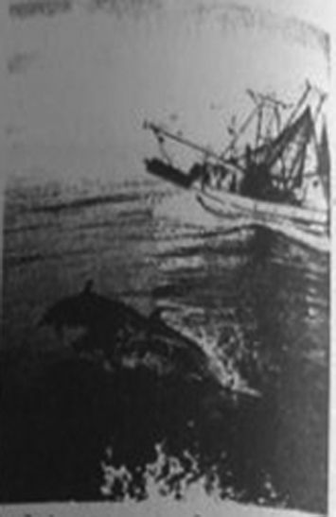
Many people say dolphins are intelligent. They seem to be able to think, understand and learn things quickly. But are they as smart as humans, or are they more like cats and dogs? Dolphins use their brains quite differently from the way humans do. But scientists say dolphins and humans are very similar in some ways. How?
Like humans, every dolphin has its own“name”. The name is a special whistle(哨声). Each dolphin chooses a specific(特有的)whistle for itself, usually by its first birthday. Dolphins are like people in other ways, too. They“talk”to each other about a lot of things—such as their age, their feelings, and finding food. They also use a system of sounds and body language to communicate. Understanding dolphin conversation is not easy for humans. No one“speaks dolphin”yet, but some scientists are trying to learn.
Dolphins are also social animals. They live in groups called pods, and they often join others from different pods to play games and have fun—just like people. Scientists believe playing together is something only intelligent animals do.
Dolphins and humans are similar in another way:both species make plans for getting things they want. In the seas of southern Brazil, for example, dolphins use an intelligent plan to get food. When there are fish near a boat, dolphins signal(发信号)to the fishermen to put their nets in the water. Using this method, the men can catch a lot of fish. Why do dolphins help the men? There is an advantage for them: they get to eat some of the fish that escape(逃脱)from the net.
1.What is a dolphin’s“name”?
A.It is a kind of game. B.It is a body sign.
C.It is a dolphin’s age. D.It is a specific sound.
2.What does the underlined word “others”refer to?
A.Other fishes. B.Other people.
C.Other dolphins. D.Other games.
3.What can we infer from the passage?
A.Some scientists can understand dolphins’ system of sounds.
B.Dolphins probably help fishermen by using their body language.
C.Humans join dolphins’ groups to get things we want.
D.Dolphins can talk to humans about their age and their feelings.
4.What’s the main idea of the passage?
A.Dolphins can communicate with each other at birth.
B.Dolphins are social animals because they play together.
C.Dolphins are smart and are like humans in some ways.
D.Dolphins help humans do many things like catching fish.

九
Being a teenager can be challenging,but it can also be exciting.You’re becoming more independent and making decisions for yourself.You are also learning to take risks and solve problems better.And changes are happening throughout your body,even in your brain.
The changes in your brain are influencing how you develop into an adult.Imagine the structure(结构) of your brain is like a big road map.Lots of roads lead to different destinations(目的地).When you were a child,as you learnt new things,your brain created more and more roads to different destinations.By the time you become a teenager, many different roads lead to the most important places on the map.Now your brain’s job is to make that map more efficient.
As a result,your experiences as a teenager actually influence the way that your brain develops.If you spend hours playing video games,what skills do you use?You learn to see something with your eyes and respond to it with your hands.As you develop those skills,your brain is making sure that the roads leading to them are especially fast and efficient.So,your video-game playing could be preparing you for a career such as a pilot.
This is a great time for you to practice new skills and discover what you’re good at and try what you love doing.Go out and try different activities,and stick to them if you think they’re useful.Remember that with everything you do,you’re shaping your brain for the future.
1.What happens as children learn new things?
A.Their brains make the maps more efficient.
B.The structures of their brains are like big road maps.
C.Their brains create more roads to different destinations.
D.Many different roads lead to the most important places.
2.What does the underlined word“it”in Paragraph 3 refer to?
A.Your brain. B.Something you see.
C.Your skill. D.Something you learn.
3.What’s the writer’s advice for teenagers?
A.Teenagers should learn to be more independent.
B.Teenagers should work harder and more efficiently.
C.Teenagers should play more video games in order to be a pilot.
D.Teenagers should experience more and stick to the useful activities.
4.Which would be the best title for the passage?
A.Making Decisions for Yourself.
B.Developing Your Brain for the Future.
C.Ways of Changing Your Brain.
D.Changes Happening in Your Brain.
十
I grew up poor—living in a big family with six brothers, three sisters, my father, and a wonderful mother. We had little money, but plenty of love and attention. I was very happy and energetic. I understood that no matter how poor a person was, he could still afford a dream.
My dream was sports. By the time I was sixteen, I could throw a ninety-mile-per-hour fastball and hit anything that moved on the baseball field. I was also lucky:my high school coach was Ollie Jarvis, who not only believed in me, but taught me how to believe in myself. One special incident(事件)with him changed my life forever.
It was the summer between my junior and senior years, and I was offered a summer job. This meant a chance for money in my pocket—money for dates with girls, money for a new bike and new clothes, and I could begin to save money for a house for my mother.
Then I realized, to do that work, I would have to give up summer baseball training. When I told Coach Jarvis, he was as angry as I expected him to be.“You have your whole life to work,”he said.“Your time for playing isn􀆳t long. You can’t afford to waste it.”
I stood before him with my head hanging, trying to think of the words that would explain to him why my dream of buying my mom a house was worth facing his disappointment in me.
“How much are you going to make at this job, son?”he asked.
“Three twenty-five an hour,”I replied.
“Well,”he asked,“is $3.25 an hour the price of a dream?”
That question made me understand the difference between wanting something right now and having a goal for the future. I practiced hard that summer, and within the year I was chosen by a famous team to play for them, and was offered $20,000 a year.
Later, I was given a baseball scholarship to the University of Arizona, which led me to an education. In 1984 I began to play for the Denver Broncos for $1.7 million a year. And certainly, I bought my mother a beautiful large house.
1.When did the writer want to take a part-time job?
A.When he decided to buy his mother a house.
B.When he graduated from junior high school.
C.When he found it difficult to play baseball well.
D.When he thought his big family was too poor.
2.Whom should the writer thank most for his success?
A.His coach. B.His mother.
C.He himself. D.His teammates.
3.By writing the article, the writer tries to tell us that .
A.to buy a house for his family is the dream of most young people
B.trying to become a sport star is the easiest way to realize a dream
C.something we want now often has to give way to a long-term goal
D.to succeed without help from others is impossible for the young
4.What can be a proper title for the text?
A.A Part-time Job B.A House for Mom
C.A Strict Coach D.A Priceless Dream
十一
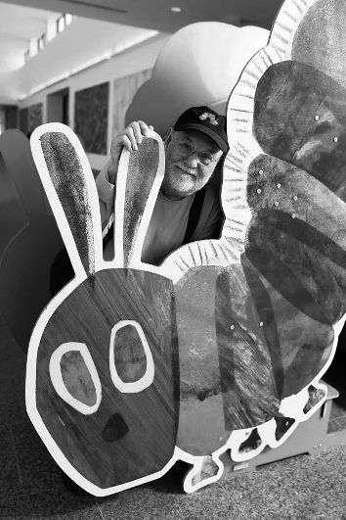
“Color,color,color!”are the words of artist Eric Carle.Eric is like the king in the world of children’s books.He has written over 70 children’s books.His most famous book,The Very Hungry Caterpillar,is common on children’s bookshelves all over the world.What most people don’t know is that Eric also makes art for adults,which is called“ArtArt”.People didn’t know about it,because he didn’t show it to the public until he was 84 years old!
Like Eric’s children’s books,his“ArtArt”is full of bright and clear color.He says that he loves color so much because he missed it during the war in Germany. Eric was born in New York in 1929,but moved to Germany with his family when he was 6.When he was 10,World War Ⅱ began.He noticed that all the houses and buildings in his town were painted grey,brown or dark green.It was a sad time,and it seemed like there was no color anywhere.
At the end of the war,“when color came back”,Eric explains,“I just loved it so much.I keep saying that I wish our eyes could see more color.Color is a very important part of my work.”
That’s true.Eric paints bright colors on paper,cuts out shapes,and then glues them onto another piece of paper.This method is called collage.In fact,it is what led Eric to his “ArtArt”.
Eric’s “ArtArt”includes large collages as well as paintings,photographs and even costumes.In all these works,he uses all kinds of colors—everything from purple to light green to orange.Now that’s a lot of color!
1.When did Eric show “ArtArt”to the public?
A.In 1929. B.In 1993.
C.In 1997. D.In 2013.
2.Why did Eric feel sad during World War Ⅱ?
A.Because he could hardly see bright color.
B.Because he had to join the army to fight.
C.Because he couldn’t draw very good paintings.
D.Because he lived a very poor life with his parents.
3.Which of the following is TRUE according to the passage?
A.Collage plays an important part in Eric’s book “ArtArt”.
B.Children know little about The Very Hungry Caterpillar.
C.Eric has created more books for adults than for children.
D.Eric moved to Germany with his family when he was 10.
4.What’s the main idea of this passage?
A.Eric created collages for his books.
B.Eric’s “ArtArt”is popular with people.
C.Eric’s love for color led him to success.
D.Eric is the king in the world of children’s books.
十二
Are You Right Handed or Left Handed?
Which hand do you use when you write? About 8 to 15 percent of people are left handed. They often have to use tools that are designed for right-handed people. So it is difficult for left-handers to use most tools. If you are right handed, try this experiment:Take a knife with your left hand and try cutting a potato into pieces. Don’t be surprised if you feel awkward(别扭的).
In the past, people thought it was strange to use the left hand. Young students looked down upon their left-handed classmates. Some children were even punished for using their left hand to write. But these days parents and teachers have accepted that. In almost every school in the world, left-handed students can use their left hand to write.
What causes people to be left handed or right handed? Experts have searched long and hard on this. They concluded(得出结论)that left-handed people are left handed for the same reason that right-handed people are right handed. One out of every ten people just is a left-hander. It􀆳s simply like the color of our eyes—some people have brown eyes, while some others have black eyes.
However, many researchers think that left-handers and right-handers are different in some aspects. Right-handers are more talkative and outgoing than left-handers. Many right-handed people understand spoken words better. For example, after they listen to directions to a supermarket, they can find it easily. Right-handers are good at organizing people, too. They are also better basketball guards. Just ask Yao Ming.
Research shows that left-handers are creative and artistic. Many famous performers, like Jim Carrey and Paul McCartney, are left handed. Many left-handers learn better visually(在视觉方面). In art, both Leonardo da Vinci and Michelangelo were left handed. In music, Ludwig van Beethoven was left handed. In science, you find Newton and Einstein. The left-handed people are also really good at tennis and other single sports.
If you prefer one hand, but you are still good at writing with the other, you are mixed handed. Research shows mixed-handers can remember everyday things better than other people. What did you eat for lunch two weeks ago? If you􀆳re mixed handed, you can probably remember.
1.If right-handers cut up potatoes with their left hand, they will .
A.get hurt B.give up cutting
C.feel awkward D.change their tools
2.What is Paragraph 2 mainly about?
A.Causes of being left handed.
B.Encouragement to left-handers.
C.Punishment for using the left hand.
D.Changes in opinions on left-handers.
3.According to the passage, right-handers .
A.learn better visually
B.are good organizers
C.are better at single sports
D.give clear directions to others
4.From the passage, we can learn that left-handers .
A.may be more talkative and outgoing
B.are ordinary people like right-handers
C.might remember everyday things better
D.no longer need to use right-handed tools

